OS LAB – Week 8

Question:
To create our own Kernel Thread, and insert it into the operating system. We also view
the log file entries to check for the modified kernel’s printed message.

#include <linux/module.h>
#include <linux/kernel.h>
#include <linux/kthread.h>
#include <linux/delay.h>

static struct task_struct *thread_st;
// Function executed by kernel thread
static int thread_fn(void *unused)
{
while (!kthread_should_stop())
{
printk(KERN_INFO "Thread Running\n");
ssleep(5);
}
printk(KERN_INFO "Thread Stopping\n");
do_exit(0);
return 0;
}
// Module Initialization
static int __init init_thread(void)
{
printk(KERN_INFO "Creating Thread\n");
//Create the kernel thread with name 'mythread'
thread_st = kthread_run(thread_fn, NULL, "mythread");
if (thread_st)
printk(KERN_INFO "Thread Created successfully\n");
else
printk(KERN_ERR "Thread creation failed\n");
return 0;
}
// Module Exit
static void __exit cleanup_thread(void)
{
printk(KERN_INFO "Cleaning Up\n");
if (thread_st)
{
kthread_stop(thread_st);
printk(KERN_INFO "Thread stopped");
}
}
MODULE_LICENSE("GPL");
module_init(init_thread);
module_exit(cleanup_thread);

Makefile:
obj-m += labwork1.o

all:
make -C /lib/modules/$(shell uname -r)/build M=$(PWD) modules

clean:
make -C /lib/modules/$(shell uname -r)/build M=$(PWD) clean

OUTPUT:

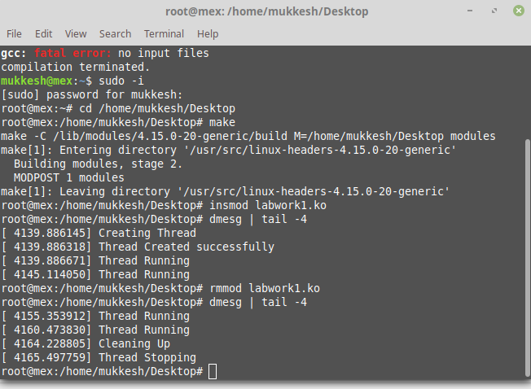
Question 2:
Print the date and time in the Linux Kernel

Code:
#include <linux/module.h>
#include <linux/kernel.h>
#include <linux/kthread.h>
#include <linux/delay.h>
#include <linux/time.h>

static struct task_struct *thread_st;
// Function executed by kernel thread
static int thread_fn(void *unused)
{
while (!kthread_should_stop())
{
time_t rawtime;
struct tm *info;
char buffer[80];

time( &rawtime );

info = localtime( &rawtime );
printk(KERN_INFO "Current local time and date: %s", asctime(info));

ssleep(5);
}
printk(KERN_INFO "Thread Stopping\n");
do_exit(0);
return 0;
}
// Module Initialization
static int __init init_thread(void)
{
printk(KERN_INFO "Creating Thread\n");
//Create the kernel thread with name 'mythread'
thread_st = kthread_run(thread_fn, NULL, "mythread");
if (thread_st)
printk(KERN_INFO "Thread Created successfully\n");
else
printk(KERN_ERR "Thread creation failed\n");
return 0;
}
// Module Exit
static void __exit cleanup_thread(void)
{
printk(KERN_INFO "Cleaning Up\n");
if (thread_st)
{
kthread_stop(thread_st);
printk(KERN_INFO "Thread stopped");
}
}
MODULE_LICENSE("GPL");
module_init(init_thread);
module_exit(cleanup_thread);

Output:
(Error faced. Linux/time.h doesn’t support time.h functions. Documentation of Linux/time.h not found)

